# 01.jpg

Widget &Vtiger Integration Document

(Demo server)

Document Revision History

This table holds record of signification changes made to the document.

|  |  |  |  |
| --- | --- | --- | --- |
| **Version** | **Date** | **Author** | **Description of change** |
| 1.1 | 08/09/2017 | Radhika Solgama | Development Document |

# Table of Contents

Table of Contents 3

1. Company Details 4

2. Project & Client Details 5

3. Initial Requirement 6

1.1 User will be created in CRM and it should get created in Dialshree 6

1.2 Campaign and list will be created in CRM &it should get created in Dial shree 7

0.3 On LIVE call of Inbound or Outbound, CRM screen will pop up with the customer details 8

0.4 Export to Dialer from CRM to Dial shree 9

0.5 Call log status will be updated in the CRM dialed from VICI dial 11

0.6 Click 2 Call 12

0.7 Dialshree Widget in the CRM 13

0.8 Create widget of Dial shree agent screen which will be placed on the top portion of the CRM screen as a frame 14

0.9 All the Function of the Dial shree agent panel will be available in this widget 15

0.10 Whenever an agent will do manual call or auto calls relevant lead will be opened in the CRM screen so that the agent will come to know to whom he is speaking with 18

0.11 Recording Start Stop Button 19

0.12 Web form button to open external Form and pass details on it 20

1. Company Details
2. Project & Client Details
3. Initial Requirement

## User will be created in CRM and it should get created in Dialshree

* When we create user in Vtiger CRM and click on save button this feature automatically create same user in DialShree with same username and password.
* When we edit user in Vtiger CRM then also using this feature we are able to update the edited information into Dialshree.

Feature requirement

* When we want to login into widget firstly we have to login into Vtiger and using vtiger's login credential we are able to login in to widget. So, for that vtiger's and Dialshree's users has to be in sync. So, by using this feature we are able to get user synchronization between Vtiger and Dialshree.

## Campaign and list will be created in CRM &it should get created in Dial shree

* When we create list from Vtiger CRM It should get created in Dialshree.

Feature requirement

* This feature is used when we want to export data from Vtiger to Dialshree into any particular list. So, using this feature we can create list from Vtiger and upload data into that list.

## On LIVE call of Inbound or Outbound, CRM screen will pop up with the customer details

* When we dial inbound or outbound call from widget relevant lead of that customer should open in Vtiger CRM screen.
* In this feature when we dial any number from widget if any information related to that number is already available in CRM then lead information page of that number is open in edit mode or if there is no information of that number in CRM then new lead page is open in edit mode.

Feature requirement

* When Agents dial any inbound or outbound call from widget and they want to store customer's information given by them then they have to open lead manualy.So, with this feature we resolved that problem.
* By using this feature when agent will dial any number from widget if any information related to that number is already available in CRM then lead information page of that number is open in edit mode so agent can easily get customers details and also can edit that details.
* If there is no information of that number in CRM then new lead page is open and agent can easily fill details of customers.
* In Below screen shot you can see when we get live call relevant lead page is getting open.

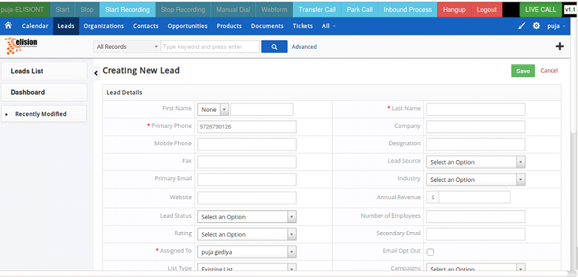

## Export to Dialer from CRM to Dialshree

* When data to be uploaded in CRM screen and then it can be pushed to Dialer via Export to Dialer function.
* We can select data from CRM which we want to export to Dialshree using Export to Dialer functionality.
* For that we have to go into lead menu into CRM then go into action and click on export to dialer. You will get below screen ,

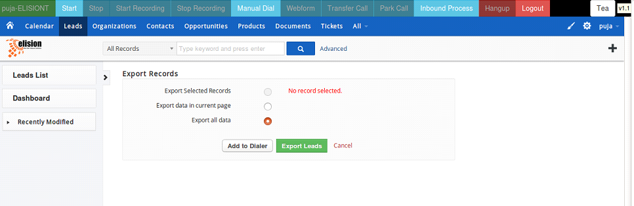

* Now click on Add to Dialer Button you will get below given screen ,

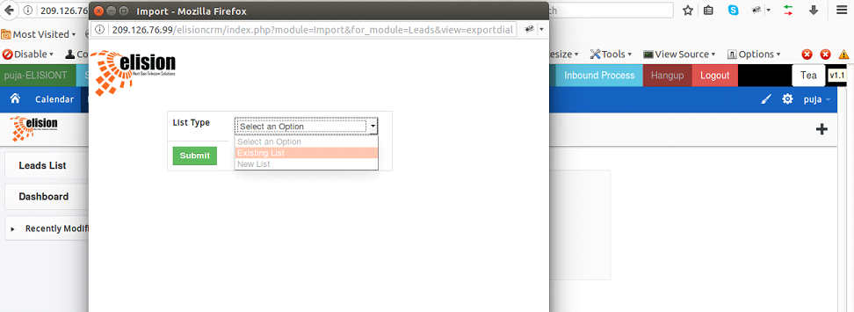

* Now if you want to export data into existing list id then select that option you will find all existing lists available in Dialshree now select any list and then click on submit button. Now check in Dialshree you will get exported leads into list id you were selected.
* Now if you want to export data into new list id the click on new list you will get below information ,

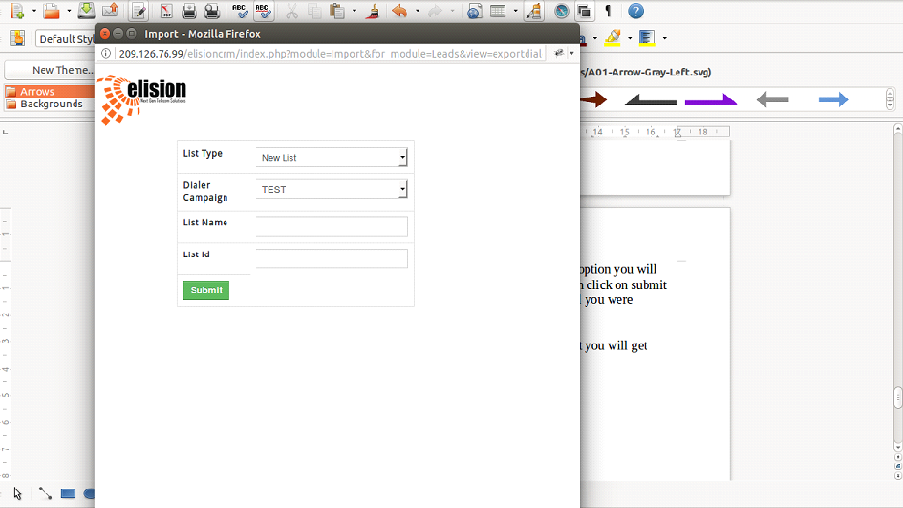

* Now select any campaign and add list name and list id and click on submit button. Now check in Dialshree you find list id which you had created.

Feature requirement

* This feature is used when we want to export data from Vtiger to Dialshree into any particular list. So, using this feature we can create list from Vtiger and upload data into that list.

## Call log status will be updated in the CRM dialed from VICI dial

* When we dial call from widget and we want log of all calls dialed from widget then using this feature we are able to get logs.
* For logs click on lead whose logs you want to check. Now click on call log you will get below screen ,

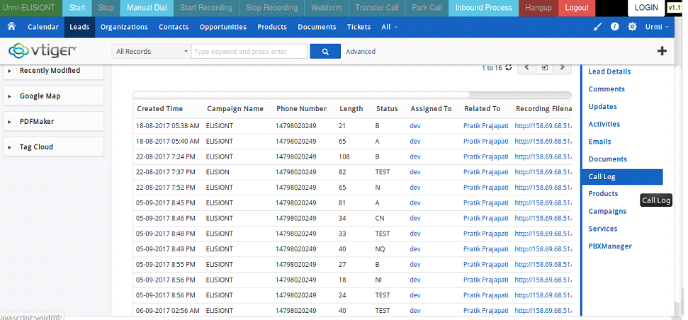

* In log you will get details like how many times particular lead was dialed from which campaign and you will also get call length , status , recording file of that lead.

Feature requirement

* So using this feature one can get details of calls i.e. logs of calls and other information like campaign, call length, and lead status and recording file.

## Click 2 Call

* This feature is used to do call directly from Vtiger CRM.
* For click 2 call you have to open lead page and then click on Headphone button as shown below ,

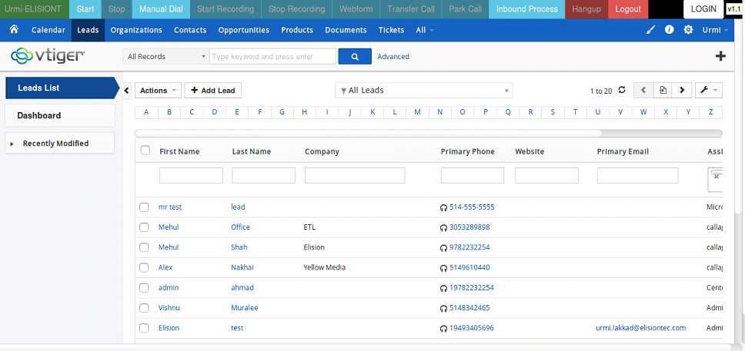

* By clicking that one call will lend to widget and other call will generate on customer number.

Feature requirement

* When customer's phone number is already there into Vtiger CRM and agent want to call on that number just by clicking headphone button they are able to call that number.

## Dialshree Widget in the CRM

* In this you will get widget which has all the feature of agent panel on the top of Vtiger CRM screen.

Feature requirement

* Purpose of this is agents do not have to toggle form CRM to agent screen or from agent screen to CRM.They both are in same screen so both can communicate easily.

## Create widget of Dial shree agent screen which will be placed on the top portion of the CRM screen as a frame

* In this you will get widget which has all the feature of agent panel on the top of Vtiger CRM screen.

Feature requirement

* Purpose of this is agents do not have to toggle form CRM to agent screen or from agent screen to CRM.They both are in same screen so both can communicate easily.

## All the Function of the Dial shree agent panel will be available in this widget

* All the feature of Dialshree agent panel like manual dial , auto dial , pause/resume ,
* Park, transfer, hang up disposition selection are available in dialer widget.

Manual Dial: It is used for dial any number manually.

1. Click on manual dial button
2. Enter phone number with country code and click on dial button

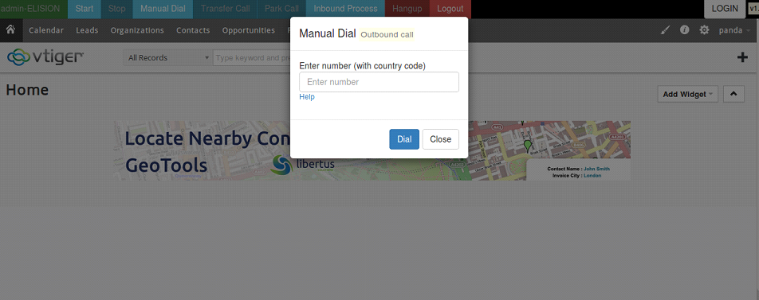

Auto Dial: This is used to automatically dial phone numbers.

1. Click on start button it will staring dialing numbers automatically.

When you want to stop auto calling click on stop button you will get pause code screen as below, by selecting any pause code you auto dialing will stop.

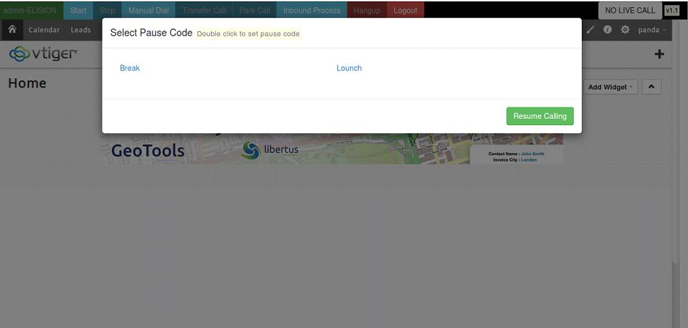

Transfer Call: This is used to transfer any call to other number or other agent.

* Click on transfer call
* Transfer call pop-up open
* Select any option from External number, Internal transfer, Agent transfer
* After that select hang up call from leave 3 way-call , hang-up both line ,hang-up Xfer line

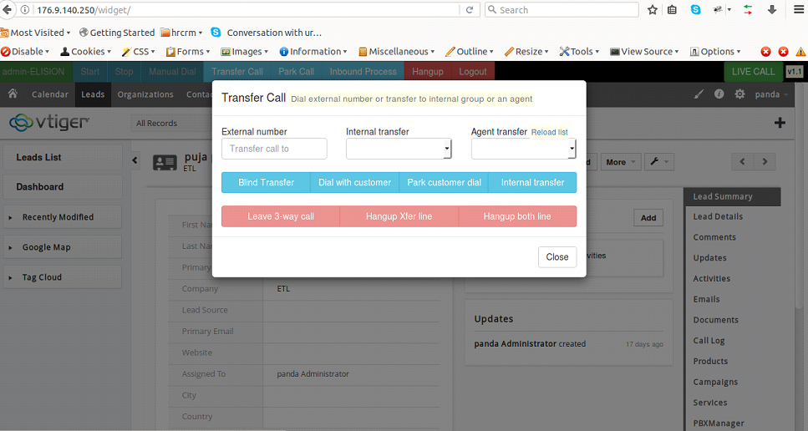

Park: If you want to park customer you can park customer by clicking on Park button. When you want to grab parked call you can grab it from clicking grab button.

Hang up: After call finish click on hang up button .By clicking that you will get disposition pop-up select any disposition by clicking that disposition.

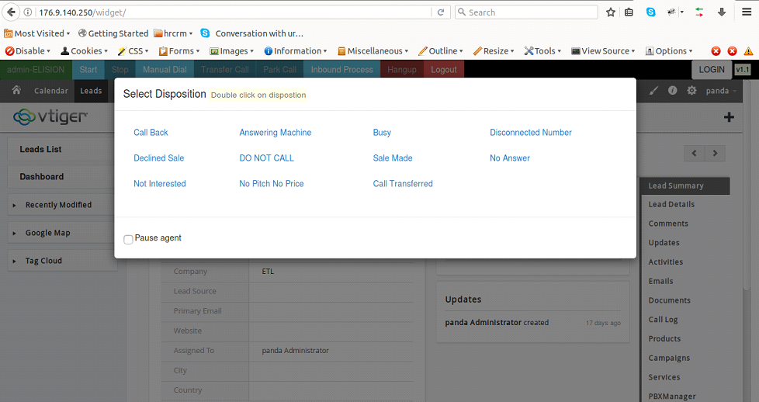

Inbound process: when you want to select any inbound process click on inbound process button you will get below screen,

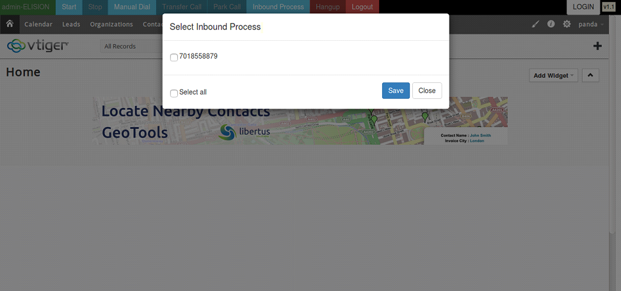

## Whenever an agent will do manual call or auto calls relevant lead will be opened in the CRM screen so that the agent will come to know to whom he is speaking with

Same as Point 3

## Recording Start Stop Button

* Using recording start and stop button we can record the conversation.
* If you want to record any conversation set Campaign Recording parameter in campaign to ONDEMAND.
* Now when you got live call and you want to record conversation click on Start recording button and when you want to stop recording click on stop recording button.

Feature requirement

* We can start and stop recording during live call whenever we want.

## Web form button to open external Form and pass details on it

* When we want to open an external form from widget this feature is used.
* Firstly set web form URL into campaign.
* Now when we get live call click on web form button new tab will open based on web form URL you set in campaign.

Feature requirement

* By clicking web form button we can open an external form.



